INVESTMENT PREFERENES AND BEHAVIOR ANALYSIS PROJET REPORT

Data Analysis Using Microsoft Excel

Submitted By Submitted To:
Subasri R Cognifyz Technologies

Internship: Data Visualization Intern
Ref: CTI/A1/C282854
Dataset: Investment Preferences and Behavior Dataset
Tools Used: Microsoft Excel

Date of Submission: 26.01.2026

Investment Preferences and Behavior Analysis Report

Introduction

This report presents an analysis of participants’ investment behavior using survey data. The objective of the study is to understand investment preferences, savings objectives, information sources, investment duration, expectations, and relationships between selected factors. Microsoft Excel tools such as Pivot Tables, charts, and slicers were used for analysis and visualization.

Dataset Description

The dataset titled “Investment Preferences and Behavior Dataset” contains participant-level information with the following key columns:

- Gender
- Age
- Investment Avenues
- Mutual Fund
- Equity Market
- Debentures
- Government Bonds
- Fixed Deposit
- PPF
- Gold
- Stock Market
- Savings Objective
- Reasons for choosing Equity, Mutual Funds, and Fixed Deposits
- Investment Duration
- Investment Monitoring
- Expected Returns
- Expectations
- Source of Investment Information

Tools Used:

Microsoft Excel

Pivot Tables

Charts (Bar, Pie, Donut, Radar, Column etc.…)

Slicers and Dashboard Features

Task 1

Gender Distribution Analysis

Objective: To analyze the gender composition of participants.

Methodology:

COUNTIF was used to calculate the number of participants in each gender category.

A pie chart was created to visualize gender distribution.

Outcome: The chart clearly shows the proportion of male and female participants in the dataset, providing an overview of demographic distribution.

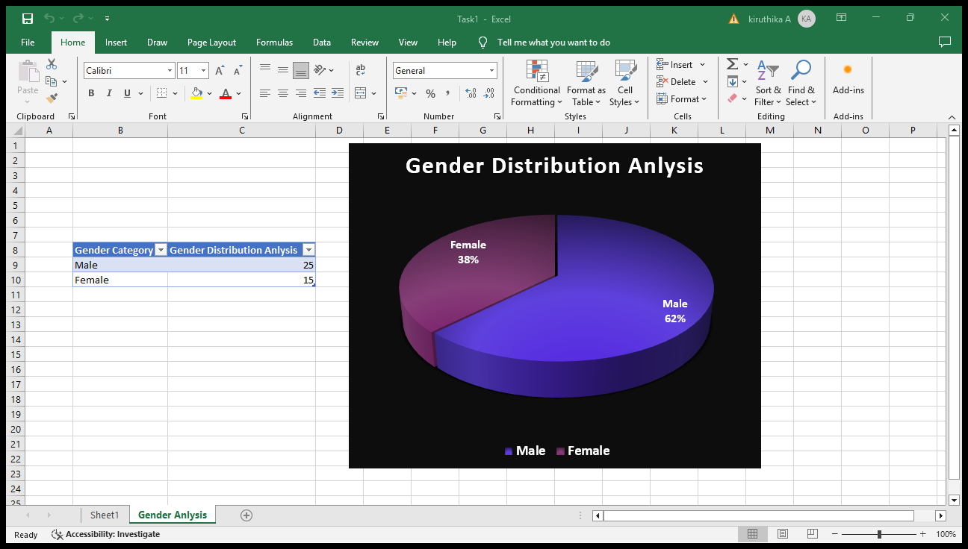

Task 2

Investment Preferences Analysis

Objective: To analyze the distribution of participants across different investment avenues and the reasons for their choices.

Methodology:

Since investment avenues were recorded as separate Yes/No columns, COUNTIF functions were used to calculate the number of participants investing in each avenue.

A bar chart was created to display the distribution of investment avenues.

Pivot Tables were used to summarize reasons for choosing Mutual Funds, Equity Market, and Fixed Deposits.

Grouped bar charts were used to visualize the reasons for investment choices.

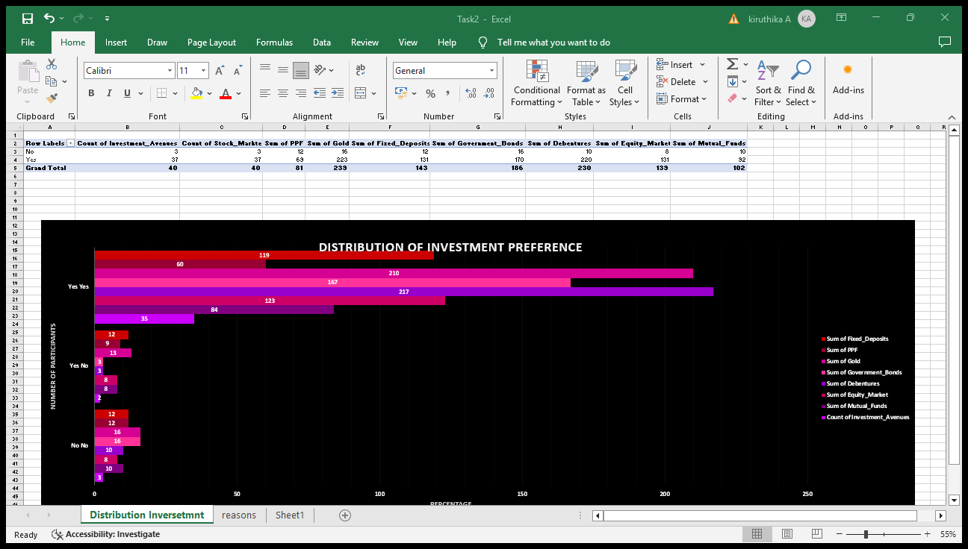
Outcome: The analysis highlights the most preferred investment avenues and the key reasons influencing participants’ investment decisions.

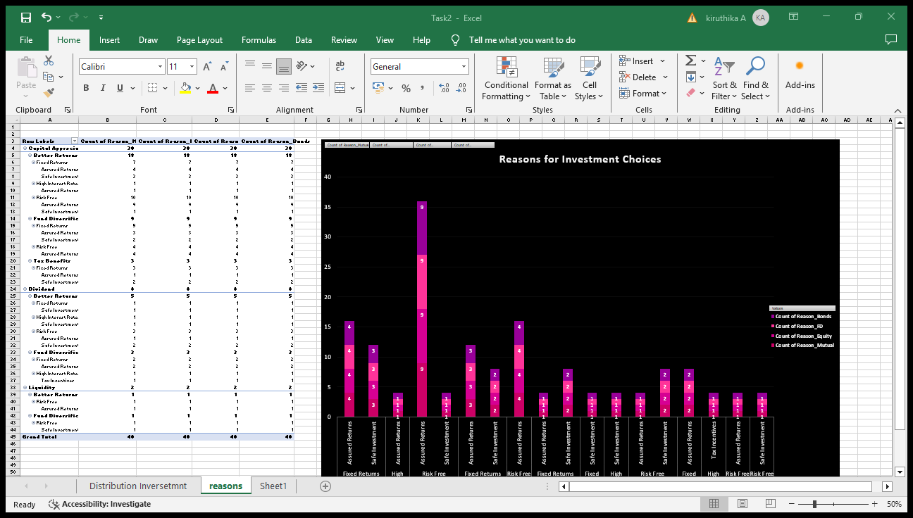

Task 3

Savings Objective and Source Analysis

Objective: To analyze participants’ savings objectives and common information sources.

Methodology:

Pivot Tables were used to summarize savings objectives.

A donut chart was created to represent the distribution of savings objectives.

Pivot Tables were also used to summarize sources of investment information.

A horizontal bar chart was created to show the frequency of each information source.

Outcome: The visualizations provide clear insights into why participants save and where they obtain investment-related information.
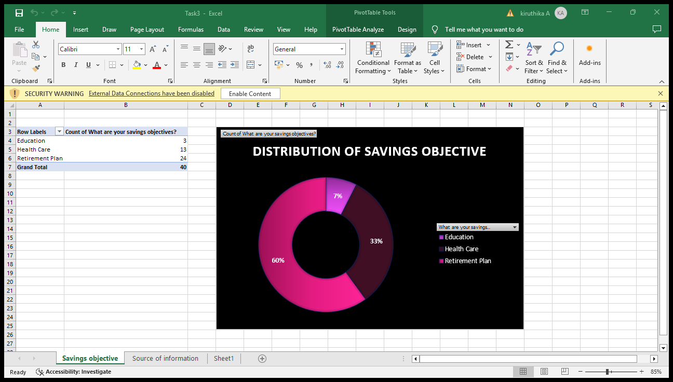

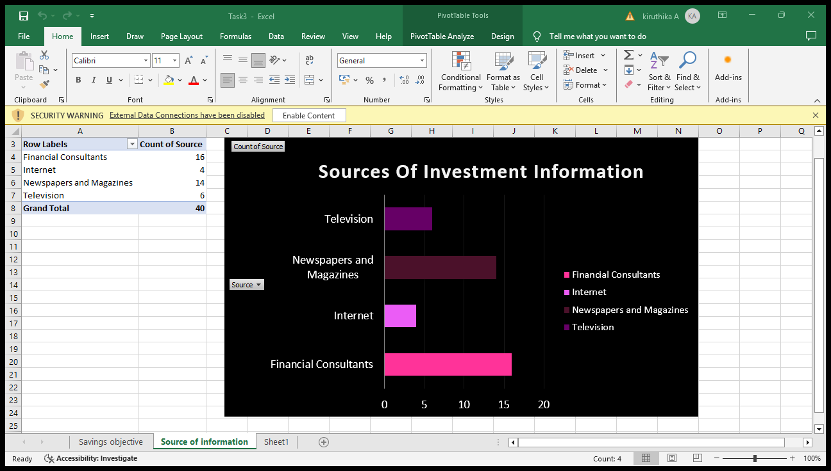

Task 4

Duration and Expectations Analysis

Objective: To analyze investment duration preferences and participants’ expectations from investments.

Methodology:

Pivot Tables were used to summarize investment duration categories.

As duration data was categorical, a column chart was used instead of a clustered bar chat to show distribution.

Pivot Tables were used to summarize participants’ expectations.

A radar chart was created to visualize different investment expectations.

Outcome: The analysis shows preferred investment durations and the relative importance of various expectations such as safety and returns.
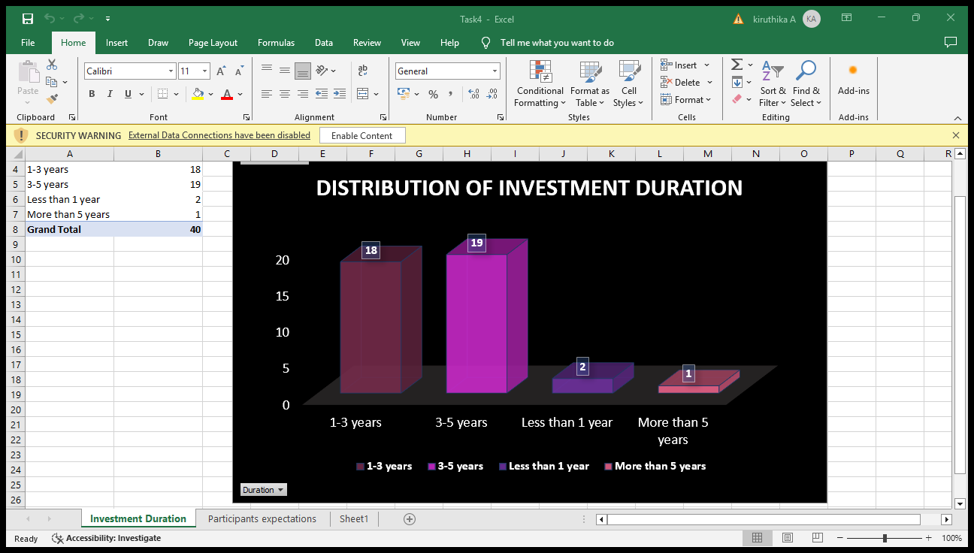

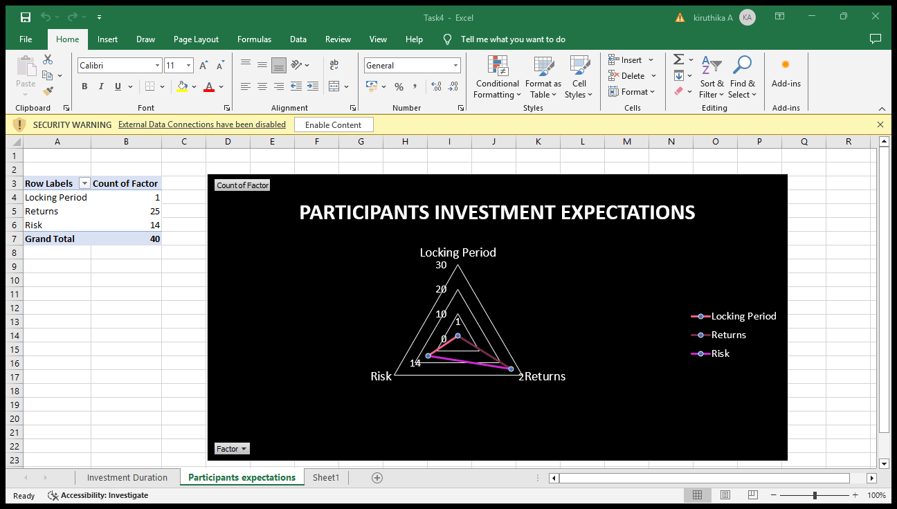

Task 6

Dashboard Creation

Objective: To combine key visualizations into an interactive Excel dashboard.

Methodology:

Selected key charts from previous tasks were placed on a dedicated dashboard sheet.

Slicers were added for interactive filtering.

All charts were linked to the dataset to enable real-time updates.

Outcome: An interactive dashboard was created, allowing users to explore investment behavior dynamically.
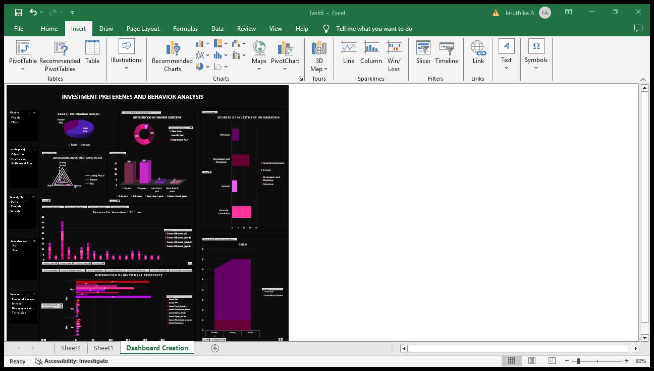

Conclusion

This project successfully analyzed investment behavior using Excel tools. The findings provide insights into participant preferences, motivations, and expectations. The use of charts, pivot tables, and an interactive dashboard enhances data interpretation and supports informed decision-making.

